Sentiment Analysis – Project report

Author:Balaji K

Project Type:Individual Project
Git Repo Link:

https://github.com/balajikrishnapillai

/CodeAlpha_sentiment-analysis
EXECUTIVE SUMMARY
The Sentiment Analysis project is developed using Python to analyze the emotional tone of book titles extracted from a dataset. The project uses Natural Language Processing (NLP) techniques to classify book titles into Positive, Negative, or Neutral categories based on sentiment polarity scores.
Using TextBlob for sentiment analysis and Matplotlib for visualization, the project converts textual data into meaningful emotional insights. The results are displayed both in tabular format and as a pie chart to understand sentiment distribution clearly.
This project demonstrates fundamental NLP concepts and practical text analytics skills.
PROJECT OVERVIEW
Objective
To perform sentiment analysis on book titles and classify them into emotional categories using Python.
Scope
• Load dataset using Pandas
• Apply sentiment polarity scoring using TextBlob
• Classify text into Positive, Negative, or Neutral
• Display sentiment distribution
• Visualize results using pie chart

DATASET DESCRIPTION
File Name: books_data.csv
Columns Used:
• Title
Total Records: Based on scraped dataset
Data Type: String
TECHNICAL IMPLEMENTATION
Technology Stack
• Programming Language: Python
• Data Handling: Pandas
• NLP Library: TextBlob
• Visualization: Matplotlib
• Development Tool: VS Code / Jupyter Notebook
WORKFLOW IMPLEMENTATION
Data Loading
The dataset is loaded using Pandas:
df = pd.read_csv("books_data.csv")
Sentiment Function
A custom function get_sentiment() is created:
• Polarity > 0 → Positive
• Polarity < 0 → Negative
• Polarity = 0 → Neutral
TextBlob analyzes the polarity score of each book title.

Sentiment Classification
A new column called Sentiment is added to the dataset:
df["Sentiment"] = df["Title"].apply(get_sentiment)
Sentiment Distribution
The frequency of each sentiment category is calculated using:
df["Sentiment"].value_counts()
Visualization
A pie chart is generated to represent sentiment distribution visually:
• Displays percentage of Positive, Negative, and Neutral titles
• Makes interpretation easier and more interactive
ANALYSIS PERFORMED
Text Polarity Analysis
Each book title is evaluated using TextBlob’s polarity scoring system.
Sentiment Categorization
Titles are grouped into three emotional categories.
Visual Representation
Pie chart shows the proportion of sentiments in the dataset.
KEY INSIGHTS
• Most book titles tend to fall under Neutral sentiment
• Few titles express strong positive or negative emotion
• Short titles often result in Neutral polarity
• Sentiment analysis works effectively on textual data
PERFORMANCE
• Efficient sentiment classification
• Accurate polarity-based categorization
• Clear graphical output
SOURCE CODE IMPLEMENTATION (Screenshot)
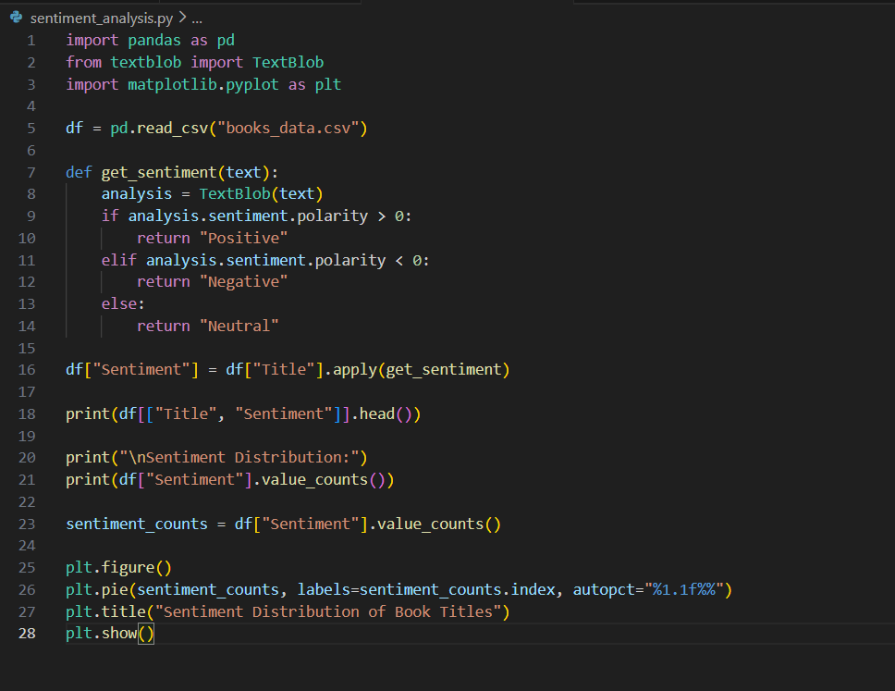

Extracted Job Result:

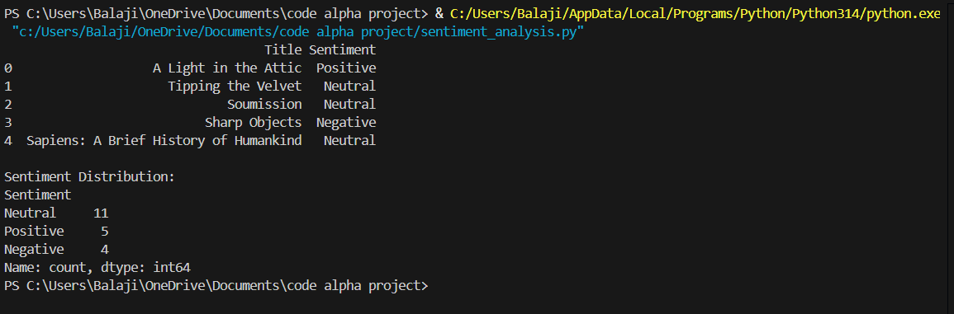

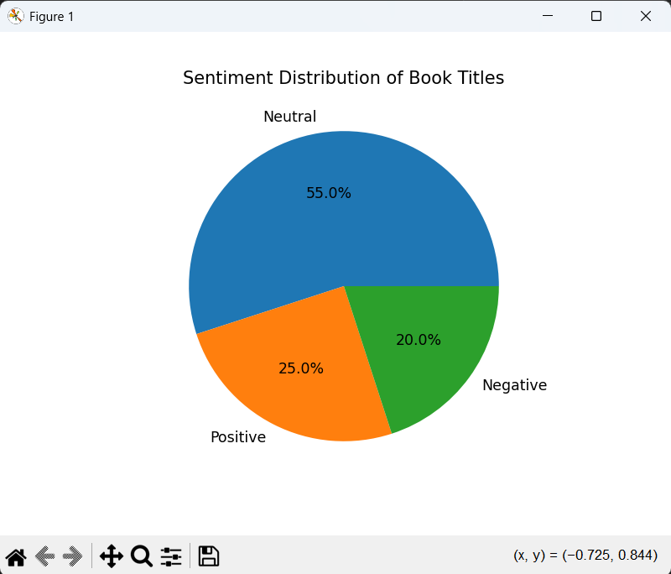

CONSTRAINTS
• Sentiment analysis applied only to Titles (not full descriptions)
• TextBlob uses rule-based polarity (not deep learning based)
• Limited emotional granularity (only 3 classes)
• Small dataset size

FUTURE ENHANCEMENTS
• Analyze full book descriptions instead of titles
• Use advanced NLP libraries like NLTK or SpaCy
• Apply transformer-based models (BERT)
• Create interactive dashboard using Plotly
• Perform sentiment trend comparison with ratings

CONCLUSION
The Sentiment Analysis of Book Titles project successfully demonstrates how textual data can be analyzed to extract emotional insights using Python. By leveraging Pandas for data handling, TextBlob for sentiment scoring, and Matplotlib for visualization, the project transforms simple text into meaningful analytical results.

